|  |  |  |  |  |  |
| --- | --- | --- | --- | --- | --- |
|  |  |  | |  | |
|  |  |  | |  | |
|  |  |  | |  | |
|  |  |  | |  | |
| **Concept of P value** | | | | | |
| **P value** | **Notation** | | **Level of Significance** | | **Results** |
| **0.000 to 0.010** | **\*\*** | | **Highly Significant** | | **Reject NH at 1 % level** |
| **0.011 to 0.050** | **\*** | | **Significant** | | **Reject NH at 5 % level** |
| **0.051 to 1.000** | **No star** | | **Not Significant** | | **Accept NH at 5 % level** |
| **0.000 denoted as < 0.001\*\*** | | | | | |

**Category of statistical Test using suitable Measurement of scale**

|  |  |  |  |  |  |
| --- | --- | --- | --- | --- | --- |
| **S.No** | **Name of the test** | **Type of Test** | **No. of variables** | **Measurement scale of First variable** | **Measurement scale of Second variable** |
| **1** | **t test for single mean** | **Parametric** | **One** | **Ordinal or Scale** | **-** |
| **2** | **t test for difference of two means (Independent sample t test)** | **Parametric** | **Two** | **Nominal – Two Groups** | **Ordinal**  **or**  **Scale** |
| **3** | **Paired t test (Dependent Sample)** | **Parametric** | **Two - with**  **Equal weightage** | **Ordinal**  **or**  **Scale** | **Ordinal**  **or**  **Scale** |
| **4** | **One way ANOVA** | **Parametric** | **Two** | **Nominal – More than Two Groups** | **Ordinal**  **or**  **Scale** |
| **5** | **Two way ANOVA** | **Parametric** | **Three** | **Two Nominal – Two or More than Two Groups** | **Ordinal**  **or**  **Scale** |
| **6** | **Karl Pearson Correlation Coefficient** | **Parametric** | **Two** | **Scale** | **Scale** |
| **7** | **The Wilcoxon signed rank sum test** | **Non-Parametric** | **One** | **Ordinal or Scale** |  |
| **8** | **Mann-Whitney U test** | **Non-Parametric** | **Two** | **Nominal – Two Groups** | **Ordinal**  **or**  **Scale** |
| **9** | **Wilcoxon Sign Rank Test** | **Non-Parametric** | **Two - with**  **equal weightage** | **Ordinal**  **or**  **Scale** | **Ordinal**  **or**  **Scale** |
| **10** | **Krushkal Wallis test** | **Non-Parametric** | **Two** | **Nominal – More than Two Groups** | **Ordinal**  **or**  **Scale** |
| **11** | **Friedman test** | **Non-Parametric** | **More than Two**  **with equal weightage** | **Ordinal**  **or**  **Scale** |  |
| **12** | **Spearman’s Rank Correlation** | **Non-Parametric** | **Two** | **Ordinal** | **Ordinal** |
| **13** | **Chi-square test for Goodness of fit** | **Non-Parametric** | **One** | **Nominal** | **-** |
| **14** | **Chi-square**  **test for Independence** | **Non-Parametric** | **Two** | **Nominal** | **Nominal** |

**Questionnaire** **for Role Descriptions of Employee**

Name :

Gender : 1. Male 2. Female

Age Group in years : 1. Below 25 2. 25-35 3. Above 35

Educational Qualification: 1. Professional 2. Non-Professionals

Experience in years : 1. Below 5 2. 5-15 3. Above 15

**Options given are:**

* SA - Strongly agree : 5
* A - Agree : 4
* N – Neutral : 3
* D - Disagree : 2
* SD - Strongly disagree : 1

***Work Related:***

|  |  |  |  |  |  |  |
| --- | --- | --- | --- | --- | --- | --- |
| **Sl. no** | **Content** | **SA** | **A** | **N** | **D** | **SD** |
| 1 | I am able to plan & complete my work |  |  |  |  |  |
| 2 | I am able to reach the career goal that I have set for myself |  |  |  |  |  |
| 3 | The work assign to me is creative ,challenging & freedom to deliver. |  |  |  |  |  |
| 4 | My work is regularly monitored & given feedbacks |  |  |  |  |  |
| 5 | I am supported with guidelines and directions to deliver my work |  |  |  |  |  |

***Role Clarity:***

|  |  |  |  |  |  |  |
| --- | --- | --- | --- | --- | --- | --- |
| Sl. no | Content | SA | A | N | **D** | **SD** |
| 6 | I have clear planned goals  and responsibilities for my job |  |  |  |  |  |
| 7 | I know exactly, what is expected out of my role |  |  |  |  |  |
| 8 | I feel certain about, how much authority I have in my current role. |  |  |  |  |  |
| 9 | I am aware on the customer expectations |  |  |  |  |  |
| 10 | I can relate to the importance my job has to the overall vision/mission of the organization. |  |  |  |  |  |

***Performance Related:***

|  |  |  |  |  |  |  |
| --- | --- | --- | --- | --- | --- | --- |
| **Sl no** | **Content** | **SA** | **A** | **N** | **D** | **SD** |
| 11 | My set targets are achievable |  |  |  |  |  |
| 12 | I have the liberty in taking initiatives |  |  |  |  |  |
| 13 | The job utilizes my experience, knowledge and potential to the fullest. |  |  |  |  |  |
| 14 | I have been supported with technical, domain, & soft skills training programs for my knowledge development. |  |  |  |  |  |
| 15 | The company recognizes & rewards my achievement. |  |  |  |  |  |

***Growth Opportunities:***

|  |  |  |  |  |  |  |
| --- | --- | --- | --- | --- | --- | --- |
| **Sl no** | **Content** | **SA** | **A** | **N** | **D** | **SD** |
| 16 | I am encouraged to take up higher responsibilities and explore new avenues within the preview of my work. |  |  |  |  |  |
| 17 | My short & long terms growth plan are met by giving opportunities |  |  |  |  |  |
| 18 | I have opportunities to learn and enhance my skills for my professional growth. |  |  |  |  |  |
| 19 | I am aware of the career ladder in the organization |  |  |  |  |  |
| 20 | My job provides me opportunity to excel |  |  |  |  |  |

**QUESTIONS REGARDING THE ROLE DESCRIPTION DATA:**

**DESCRIPTIVE ANALYSIS:**

1. Form the Frequency and Percentage of Gender, Age, Education and

Experience of Employees

1. Find Mean and SD for all statements regarding Role Description
2. Find Mean and SD with regard to Factors of Role Descriptions
3. Form the Frequency and Percentage of Levels of Role Descriptions

**INFERENTIAL ANALYSIS:**

1. Test whether opinion regarding “Reach the Career Goal” are above average level
2. Test whether significant difference between Gender with regard to Factors of Role Description
3. Test whether significant difference between mean towards any two Factors of Role Description
4. Test whether significant difference among Age group with regard to Factors of Role Description
5. Test whether significant difference among Age group and Gender with regard to Factors of Role Description
6. Test whether significant relationship between Factors of Role Description
7. Test whether opinion regarding “targets are achievable” are above median level
8. Test whether significant difference between Educational Qualification with regard to Factors of Role Description
9. Test whether significant difference between mean rank towards any two Factors of Role Description
10. Test whether significant difference among Experience with regard to Factors of Role Description
11. Test whether significant difference between mean rank towards Factors on Role Descriptions
12. Test whether significant relationship between Factors of Role Description (Spearman’s)
13. Test whether Level of Role Description of employees are Moderate level
14. Test whether association between Educational Qualification and Level of role description

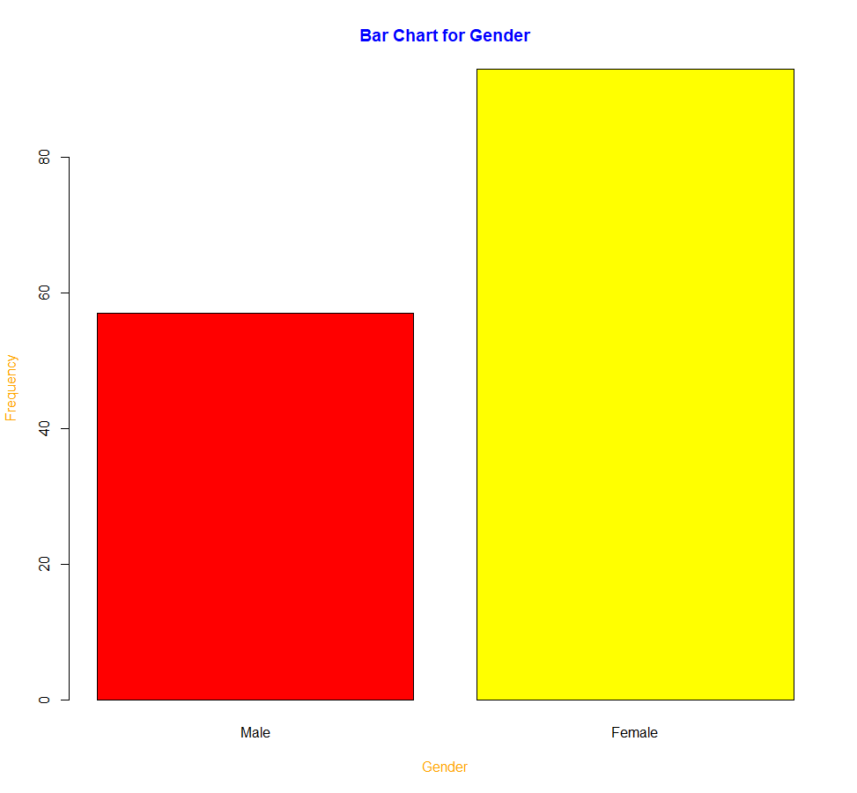

|  |  |  |  |  |  |
| --- | --- | --- | --- | --- | --- |
|  | **Mean** | **SD** | **skew** | **kurtosis** | **Standard**  **Error** |
| Q1 | 4.12 | 0.76 | -0.84 | 0.84 | 0.06 |
| Q2 | 3.81 | 0.92 | -0.57 | -0.42 | 0.07 |
| Q3 | 3.31 | 1.09 | -0.59 | -0.40 | 0.09 |
| Q4 | 3.89 | 0.79 | -1.78 | 5.06 | 0.06 |
| Q5 | 3.75 | 1.02 | -0.40 | -0.97 | 0.08 |
| Q6 | 3.59 | 1.06 | -0.33 | -1.16 | 0.09 |
| Q7 | 3.79 | 0.92 | -0.48 | -0.56 | 0.08 |
| Q8 | 3.94 | 0.94 | -0.55 | -0.63 | 0.08 |
| Q9 | 3.77 | 1.07 | -1.22 | 1.30 | 0.09 |
| Q10 | 3.62 | 1.08 | -0.40 | -0.59 | 0.09 |
| Q11 | 3.87 | 0.90 | -0.80 | 0.01 | 0.07 |
| Q12 | 3.57 | 1.06 | -1.09 | 0.72 | 0.09 |
| Q13 | 3.55 | 1.01 | -0.49 | -0.26 | 0.08 |
| Q14 | 3.84 | 0.77 | -1.22 | 1.82 | 0.06 |
| Q15 | 3.49 | 0.97 | -1.15 | 1.35 | 0.08 |
| Q16 | 3.45 | 1.23 | -0.59 | -0.83 | 0.10 |
| Q17 | 3.64 | 1.28 | -0.78 | -0.64 | 0.10 |
| Q18 | 3.51 | 0.93 | -1.47 | 1.95 | 0.08 |
| Q19 | 3.71 | 1.07 | -0.44 | -1.06 | 0.09 |
| Q20 | 3.40 | 0.92 | -1.22 | 1.49 | 0.08 |

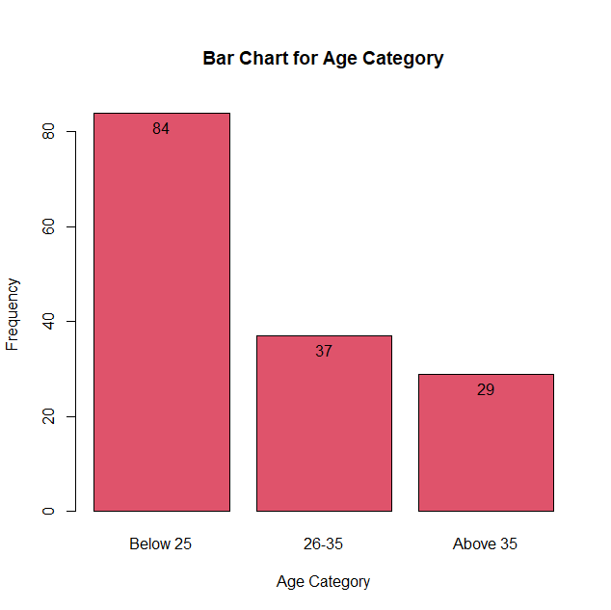

|  |  |  |  |  |  |  |  |  |  |
| --- | --- | --- | --- | --- | --- | --- | --- | --- | --- |
|  | mean | sd | IQR | 0% | 25% | 50% | 75% | 100% | n |
| GO | 17.707 | 3.889 | 4.75 | 9 | 15.25 | 19 | 20 | 24 | 150 |
| PR | 18.333 | 2.832 | 2 | 11 | 18 | 19 | 20 | 23 | 150 |
| RC | 18.700 | 3.391 | 4 | 13 | 17 | 19 | 21 | 25 | 150 |
| Total | 73.627 | 11.431 | 15.5 | 50 | 65.5 | 77 | 81 | 92 | 150 |
| WR | 18.887 | 3.305 | 5 | 13 | 16 | 20 | 21 | 25 | 150 |

